# logo

# “ClockWork” screenshots for Disability Services

2012

# Student Data

ClockWork has an extremely flexible and customizable way of keeping track of information/data for students called “Dynamic Screens”. Each “screen” in ClockWork consists of a series of data fields and is equivalent to a form – data can be entered in for a student and updated at any time. Using this system we can exactly match any existing forms your department is already using (which helps with the transition), and you are provided with the necessary tools to modify / add screens as your department changes and grows over time. Screens also allow you to organize and group different data sets and restrict access permissions. The student intake / registration form is an example of a screen.

**Figure 1.1: Administrative tool for adding & modifying data screens**

The tool that is included with ClockWork allows you to modify your screens (forms) at any time. The list on the left is a listing of all screens that are currently active along with all data fields that belong to that screen in the order that they appear. The small “Staff Info” screen and a portion of the “Student Info” screen are shown. The “Control Parameters” dialog in the center of the screenshot shows how you can edit an existing data field – the one shown is for a droplist – and each data field type has its own set of parameters. The open droplist on the far right (top) shows some of the available types of data fields you can add to a ClockWork screen. This list includes droplists, lists, checkboxes, radiobuttons, text boxes, dates, and several other types.

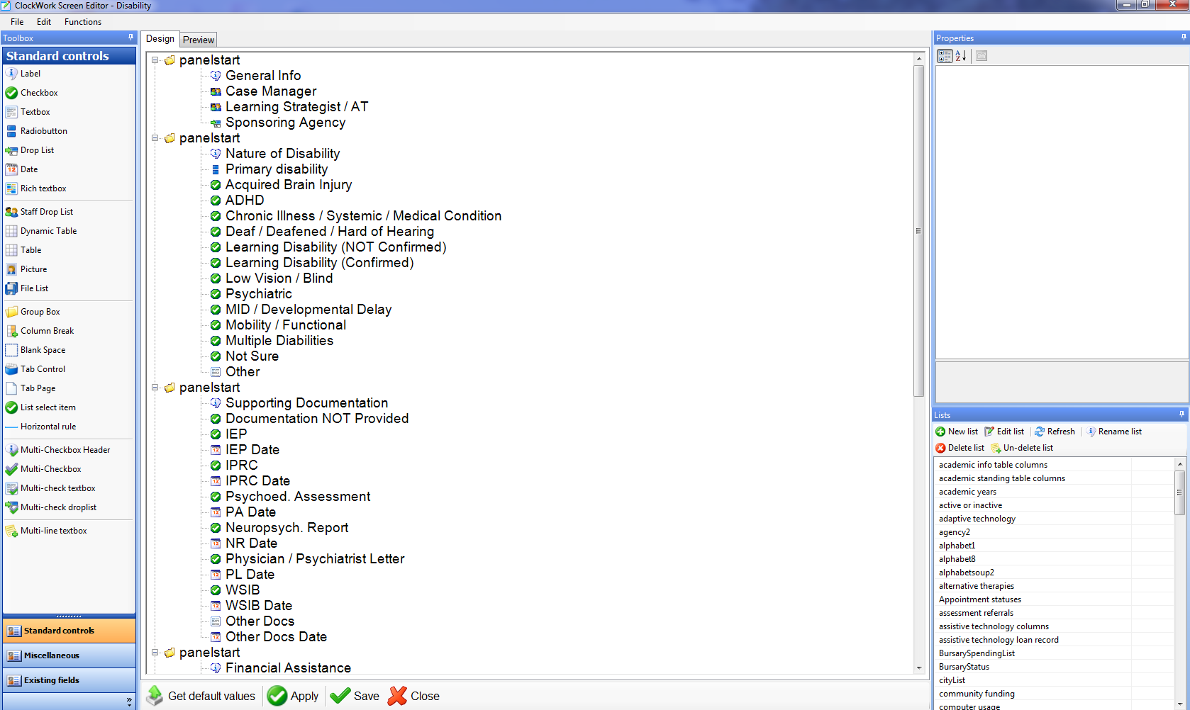

**Figure 1.2: Student intake form**

This student intake form is an example of a ClockWork dynamic screen – this is just a sample one and the actual fields & layout can be customized for each school.



**Figure 1.3: Sample screen of Student Accommodations**

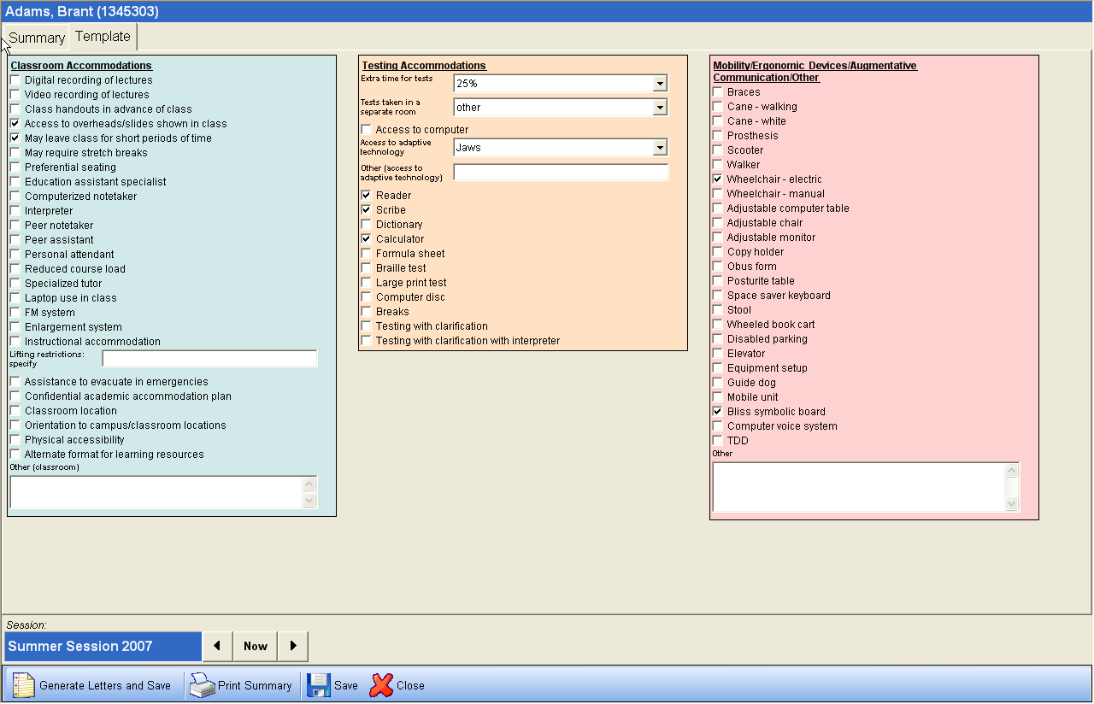

**Figure 1.4: Sample screen of Students Disability Appointment History**

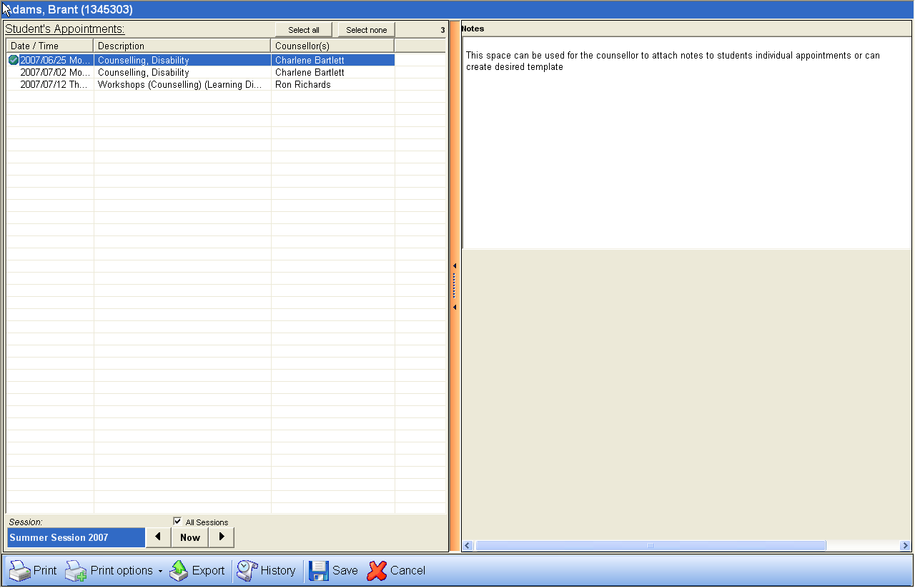**Figure 1.5: Sample screen of Learning Strategy and Assistive Technology for Students**

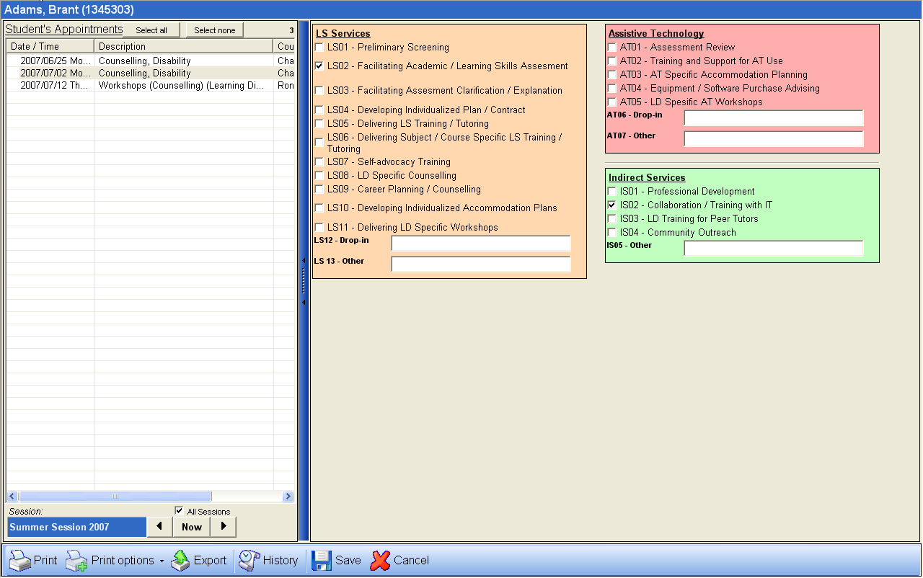

**Figure 1.6: Sample screen of General Disability Information for Students**

